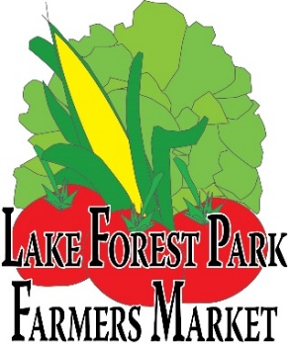

February 21, 2023

Greetings Artists, Artisans, and Crafters,

The Lake Forest Park Farmers Market invites you to apply for our upcoming Crafts Day at the Lake Forest Park Farmers Market on Sunday, July 16th. We’re delighted to offer an opportunity for local creatives to share their unique creations with our community and look forward to a wonderful event!

Please read the following application process carefully.

APPLICATION PROCESS
Please submit all application materials in PDF form via email to programs@thirdplacecommons.org. For your convenience, note that all application documents have now been converted into fillable forms that you can complete directly on your computer in MS Word.

Final applications may be printed and signed, then scanned to a pdf, or we will accept a typed signature in lieu of a handwritten signature. Submission of your application constitutes your acceptance that your typed name represents your signature.

Application packets must be complete to be considered, and must be received via email by Monday, April 3rd. Complete application packets will include:

 Completed and signed application.
 Completed and signed Market Requirements acknowledgment sheet.
 3 photographs to represent current work, clearly labeled, and described on Work Description Form.  Photocopy (scan) of your current Washington State Business License.
 **Proof of Commercial Liability insurance (all vendors)
- Coverage cannot exclude “Products – Comprehensive/Ops”
- If accepted, you must submit a Certificate of Insurance (COI) that names “Friends of Third Place Commons, dba Lake Forest Park Farmers Market” as an Additional Insured or have a blanket Additional Insured policy.
- Important Note: Short term/one-day policies are available, however some short-term policies exclude “Products – Comprehensive/Ops” coverage. Please read details of your short-term policy before purchasing. We are unable to accept COIs that exclude this coverage.
- See market insurance info sheet for full details, guidelines, and tips to find qualifying coverage.

We will notify you of your application status no later than April 17th. If you have any questions, please send a message to programs@thirdplacecommons.org, or call 206-366-3302.

If you are accepted to the market, you will be required to submit the following:
- By Friday May 5th: To reserve your spot in the market, send a check for $50 for market registration fee, payable to Friends of Third Place Commons, sent via postal mail to Third Place Commons – Lake Forest Park Farmers Market, PO Box 82355, Kenmore, WA 98028.
- By Friday, June 16th: A Certificate of Insurance naming Friends of Third Place Commons – Lake Forest Park Farmers Market as an Additional Insured via postal or email to programs@thirdplacecommons.org.
  - Please note: certificate must be current though July 16, 2023.

Please note that this is a juried event. Our goal is always to make sure we have a broad representation of media, so that everyone has a fair chance to participate and have a successful day. Our criteria remain the same: all products sold at the Lake Forest Park Farmers Market are handmade by you in the State of Washington. We also require that you personally represent your work at the event.

Thank you so much for your support of the Lake Forest Park Farmers Market! We look forward to working together to make this a great Crafts Day at the Market!

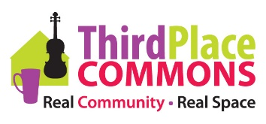

P.O. Box 82355, Kenmore, WA 98028

LFP Farmers Market CRAFTS DAY
SUNDAY, JULY 16, 2023
10:00AM – 2:00 PM
At the intersection of Ballinger Way NE and Bothell Way NE, in front of Lake Forest Park City Hall
Type in or print responses below.
Name:

Business tax ID for sales tax (photocopy of license required):
Business Name:
Mailing Address (please include zip code):

Email:

Telephone Numbers:
Work: ( ) Cell: ( )
Home: ( )

BRIEFLY describe your handcrafted items that you will personally represent at this event:

Booth Registration fee: $50.00, payable immediately upon acceptance.

Please make your check out to Friends of Third Place Commons.

Set-up begins at 8:00 AM. You are responsible for bringing your own table(s), chair(s), and canopy, no larger than 10’ square and weighted at all corners with at least 25 pounds per corner.

I certify that all products I offer for sale at the Lake Forest Park Farmers Market have been handmade by me in the State of Washington. No items made out of state will be allowed, and I understand that anyone offering such items for sale will be asked to leave the Farmers Market. I will abide by the rules and regulations of the Lake Forest Park Farmers Market. I understand that this is a juried event, and that my full and complete application packet must be received by April 3rd for guaranteed consideration. I also understand that event set-up is at the discretion of the market manager and that my space will be determined by the manager.

I agree to hold harmless the LFP Farmers Market, Friends of Third Place Commons, Merlone Geier Partners, or the City of Lake Forest Park from any and all claims and actions arising out of my participation in the Farmers Market, including loss, damage or injury to person or property. I agree that all photos and videos taken during the crafts fair may be used for communications and marketing purposes at the sole discretion of Third Place Commons.

Please return pdf packet with completed application, signed Market Requirements Acknowledgement, and images of work via email to programs@thirdplacecommmons.org.

Signature: Date:

Work Description Form

Please attach 3 color photographs to represent current work. Multiple color images combined into a single file are fine, but please ensure images are large enough to be seen clearly. Label each with the title of the work. (For example: Jay Doe, wooden toy chest.)

Name of applicant:

Photo #1

Title:

Medium (if mixed, please list all media):

Photo #2

Title:

Medium (if mixed, please list all media):

Photo #3

Title:

Medium (if mixed, please list all media):

We thank you for submitting photos that represent the work you will be selling at the Lake Forest Park Farmers Market Crafts Day. If your work varies greatly from these representations, we reserve the right to ask you to remove it from display.

Help us make Crafts Day a success!

☐ I have digital images of my artwork that I would be willing to share for promotional purposes.

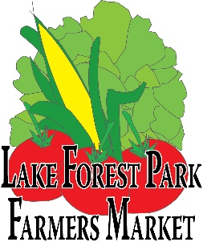

Market Requirements:
In 2020 and 2021, the farmers market was subject to a variety of COVID requirements that included mandatory masks, physical distancing, hand sanitizer made available for staff and customer use, among others.
As of Winter 2023, the market is not currently subject to any COVID related restrictions, but this could change should community transmission increase again.
In addition, according to the market’s insurer:
“It is mandatory that markets require their vendors to maintain a commercial general liability policy that does not exclude products - completed operations coverage. Policy limit should be a minimum of 1 million per occurrence with a 2 million aggregate limit. Each vendor policy needs to list the market as an additional insured or contain a blanket additional insured endorsement and provide the market with a certificate of insurance confirming coverage.”
Please review the Vendor Insurance Information Sheet carefully for details regarding these requirements.

Please read the following requirements carefully, initial each item to agree, and sign at the bottom to acknowledge receipt of and agreement to these requirements, guidelines, and limitations of liability.
I Agree:

☐ I will read and abide by any COVID related requirements that may be established by the Office of Governor Jay Inslee, Public Health – Seattle and King County, and Friends of Third Place Commons/Lake Forest Park Farmers Market.
Initials
☐ Cancelation: I understand that Friends of Third Place Commons (aka The Lake Forest Park Farmers Market) may cancel Crafts Day at the Market at any time up to the day of the event. Cancelation may occur for any reason including (but not limited to) a reduction in King County’s COVID related Phase status, directive from public health officials, or non-viability of the event for other logistical reasons. My sole remedy in case of cancelation will be the refund of my $50 registration fee. Friends of Third Place Commons will not be liable for any loss of potential revenue from the canceled event nor for any costs associated with preparing for the event. In the event of cancelation, I understand that Friends of Third Place Commons will notify me via email and I will monitor my email accordingly. Initials

Print Name: Name of Business:

Signature: Date:

